**EXPT NO : 4 A python program to implement Single Layer**

**Perceptron**

**DATE: 13.9.24**

**AIM:**

To write a python program to implement Single layer perceptron.

**PROCEDURE:**

Implementing Single layer perceptron method using the Keras dataset involve the following steps:

**Step 1: Import Necessary Libraries**

First, import the libraries that are essential for data manipulation, visualization, and model building.

|  |
| --- |
| import numpy as np |
|  |
| import pandas as pd  from tensorflow import keras  import matplotlib.pyplot as plt |

**Step 2: Load the Keras Dataset**The Keras dataset can be loaded.

(X_train,y_train),(X_test,y_test)=keras.datasets.mnist.load_data()

**Step 3: Data Preprocessing**

Ensure the data is clean and ready for modeling. Since the Iris dataset is clean, minimal preprocessing is needed.

print

(

f

"Training set:

{

X_train.shape

}

"

)

print

(

f

"Testing set:

}

X_test.shape

{

"

)

print

(

X_train

[

1

]

.shape

)

plt.matshow(X_train[

1

])

**OUTPUT :**

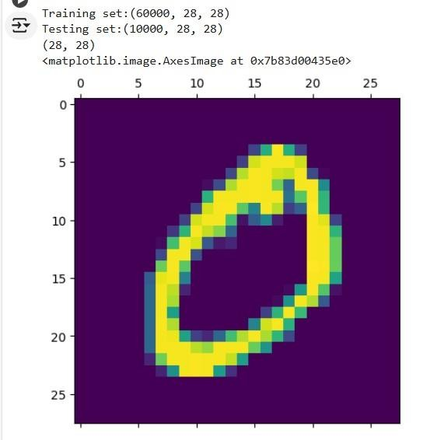

**Step 4 : Train a Model**

**#Normalizing the dataset**

**x_train=X_train/255**

**x_test=X_test/255**

**#Flatting the dataset in order to compute for model building**

**x_train_flatten=x_train.reshape(len(x_train),28*28)**

**x_test_flatten=x_test.reshape(len(x_test),28*28)**

**x_train_flatten.shape**

**Step 5 : Make Predictions**

Use the model to make predictions based on the independent variable.

|  |
| --- |
| model=keras.Sequential([  keras.layers.Dense(10,input_shape=(784,),  activation='sigmoid') |
|  |
| ]) |
|  |
| model.compile( |
|  |
| optimizer='adam',  loss='sparse_categorical_crossentropy',  metrics=['accuracy'])    model.fit(x_train_flatten,y_train,epochs=5 |
|  |
| ) |

**OUTPUT :**

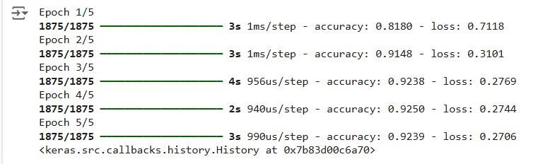

**Step 6 : Evaluate the Model** Evaluate the model performance.

model.evaluate(x_test_flatten,y_test)

**OUTPUT :**



**RESULT:**

This step-by-step process will help us to implement Single Layer Perceptron models using the Keras dataset and analyze their performance.